**Ideation Phase**

**Define the Problem Statements**

|  |  |
| --- | --- |
| Date | 26 June 2025 |
| Team ID | LTVIP2025TMID30678 |
| Project Name | To Supply Leftover Food to Poor |
| College Name | Aditya collage of Engineering and Technology |
| Team members | 1)Sadi ramana (Leader) – 22MH1A04D6   * [Ramanarebel69@gmail.com](mailto:Ramanarebel69@gmail.com)   2)Sravani kasireddy (Documentation developer and opearator ) - 23MHA0412   * [Sravanikasireddy850@gmail.com](mailto:Sravanikasireddy850@gmail.com) |

**Customer Problem Statement Template:**

Developing the customer problem statement for the project to provide surplus food to the poor necessitates clearly defining the particular issues to be addressed by the target group. Below is a step-by-step process of developing the problem statement:

Customer Problem Statement:

Problem Statement:

"Numerous individuals and families in our community are living with food insecurity because of restricted access to nutritious and affordable food. Regardless of the overabundance of excess food from local restaurants, grocery stores, and events, there is a huge gap in the effective allocation of this excess food to those who need it most. This leads to wasted food that has the potential to reduce hunger and enhance the quality of life for vulnerable populations. The relative lack of awareness, logistical barriers, and food safety issues further complicate the process of bridging surplus food with those who need it most."

Most Essential Elements of the Problem Statement:

1. Target Group: Families and individuals living with food insecurity.

2. Essential Problem: Inadequate access to wholesome and affordable food.

3. Existing Resources: Excess food from corporate entities that is wasted.

4. Negative Impacts: Wasted food that can be used to reduce hunger.

5. Barriers: Awareness, logistics, and food safety issues.

Example of a Enhanced Problem Statement:

"In our society, numerous low-income households live with food insecurity, without the ability to afford and access wholesome meals. In light of the massive quantity of surplus food produced by the local restaurants and grocery stores, however, there is no efficient mechanism in place to transfer this surplus food to the needy. This causes both wastage of food and persistent hunger among the needy. Overcoming the logistical issues, raising awareness, and maintaining food safety are most important in order to construct an efficient solution that can fill this gap."

This statement of the problem can be used as a basis for formulating strategies and programs focused on efficiently providing excess food to the poor.

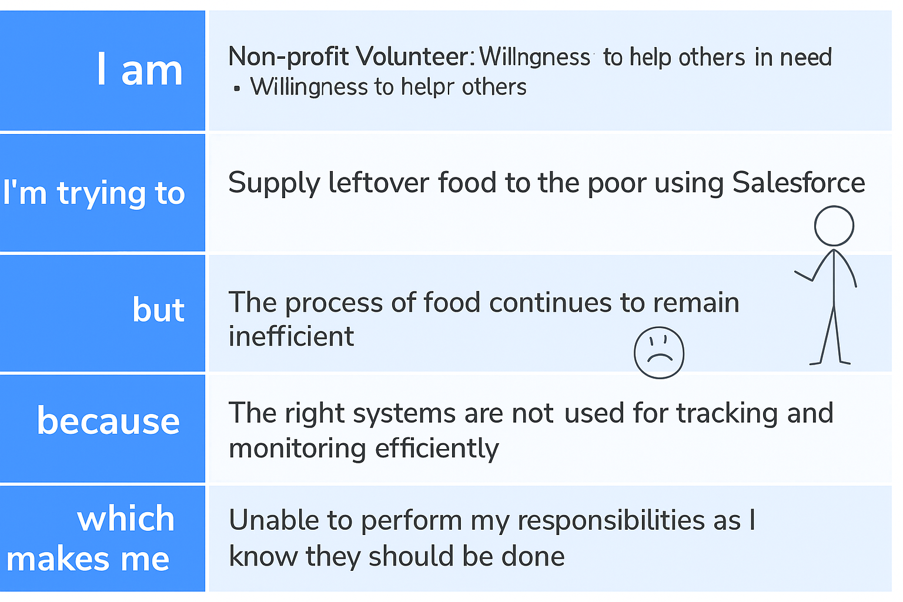

**EXAMPLE:**

